# CS 255 System Design Document Template

## UML Diagrams

### UML Use Case Diagram

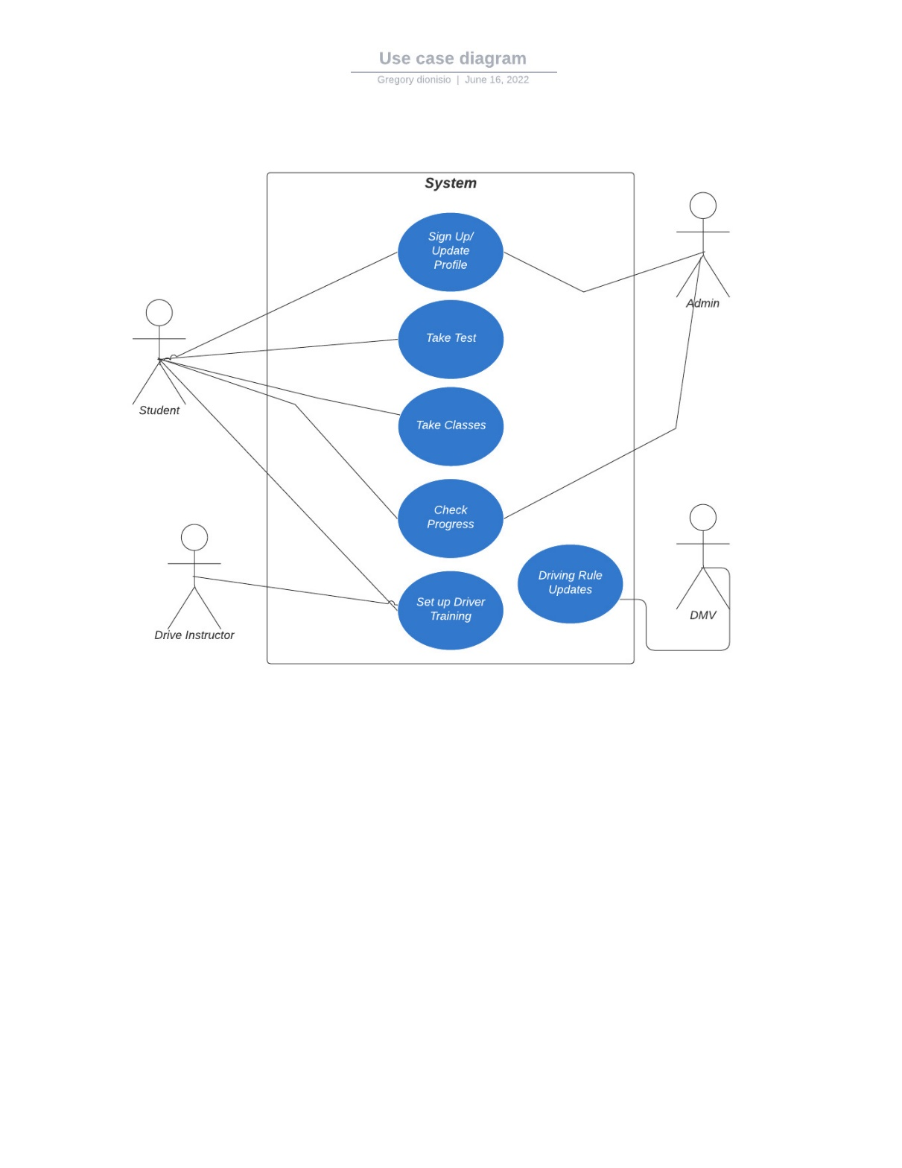

### UML Activity Diagrams

### UML Sequence Diagram

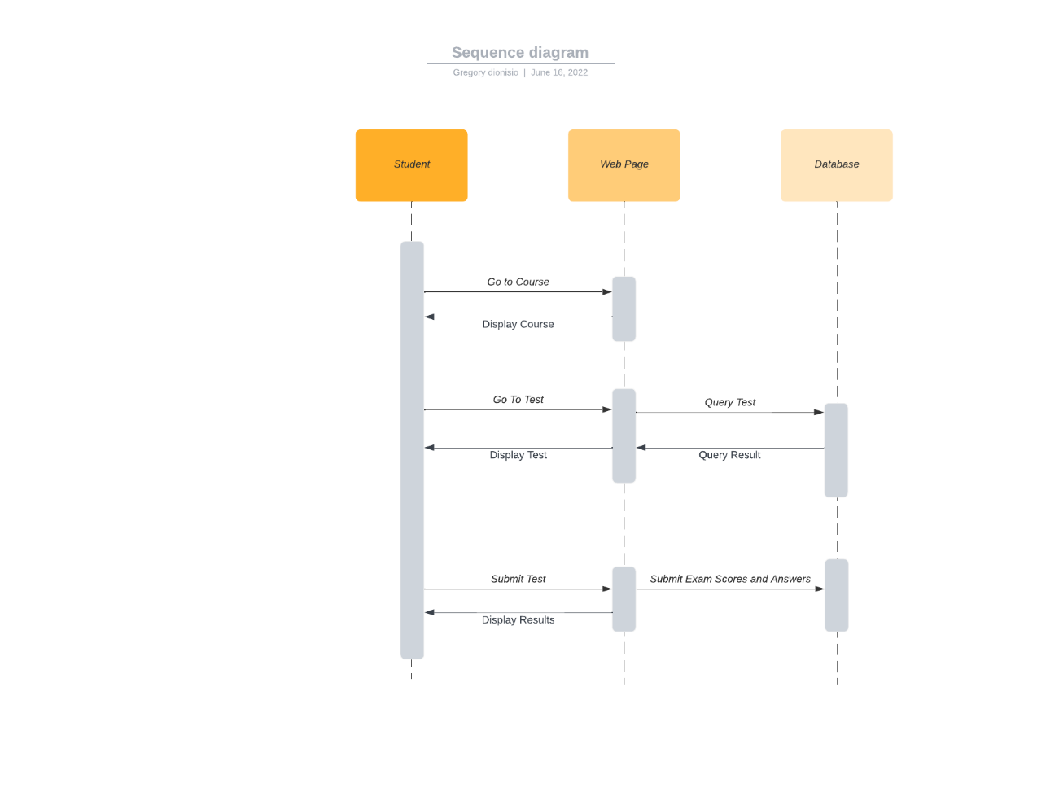

### UML Class Diagram

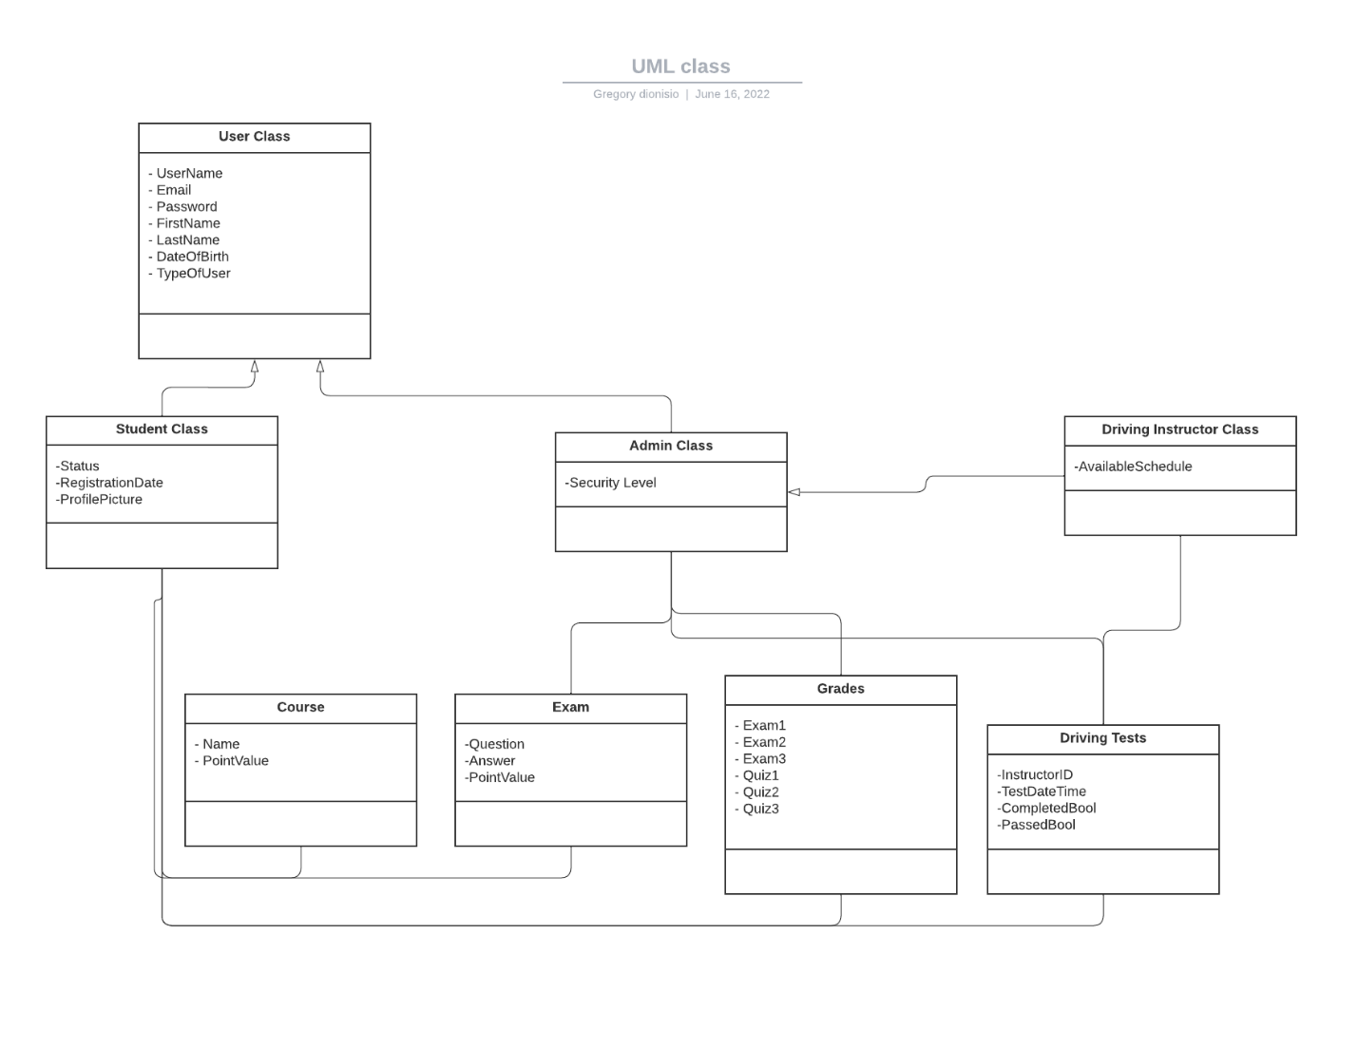

## Technical Requirements

*The Driver pass system will be built using a web-based approach so that it can be accessed over a multitude of devices through the cloud. The speed of the system will need to be fast enough to allow the number of users to access the site without complications. The system can be updated easily as needed since updating a web-based system is fairly simple to implement as opposed to a native application.* A Linux server system is the best choice for the web application to run on. There will be an SQL database used to store all the information such as user information and progress statistics. There will also need to be probably a few different programming languages to communicate with the database and properly display information to the user.